Week 1 (Feb. 16-20)
READING CAFÉ 1

“To learn to read is to light a fire;
every syllable that is spelled out is a spark.”
Victor Hugo

On the menu this week is:

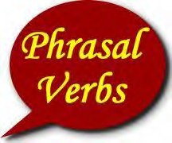PART I
VOCABULARY BUILDING

- students may do the following activity in groups.

1. Complete the sentences. Use the phrasal verb, which means the same as the verb in
brackets. Remember to write the phrasal verb in the correct form.

on
take over
up
off

1. The plane couldn't take off because of a storm. (leave the ground and fly)

2. He's going to take up photography in his free time. (start to learn)

3. The company is expanding and taking on new staff. (employing)

4. The company was taken over by a big multinational. (buy / get control of)

off
go on
down
through

5. A lot of people were injured when the bomb went off . (exploded)

6. I can’t do my work because the Internet has __ gone down__(stopped working temporarily)

7. Please go on _. I ’m very interested to hear what you have to say. (continue)

8. Let’s go through the report again to make sure we’ve included everything.(look carefully at)

around
come about
across
out

9. You became the mayor of your city? Wow! How did that __come about______? (happen)

10. The rain stopped and the sun ___came out________ (appear)
11. Right now Ellen doesn't agree with me, but I think she will _come around____ to my way of thinking soon. (change one’s mind)
12. I came accross an old school friend in the street yesterday. (met by chance)

2. Work with your partner. Choose six of the phrasal verbs and use them in your own
example sentences.

1.

2.

3.

4.

5.

6.

3. Read each example sentence to another pair but leave out the phrasal verb. See if they
can guess the missing phrasal verb.

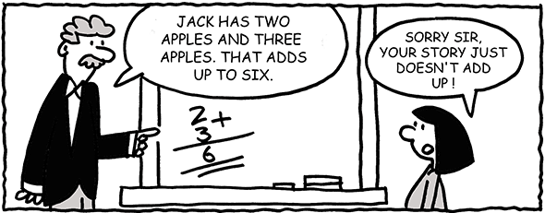

PART II
STRATEGY PRACTICE MAKES PERFECT

SKIMMING

- Skimming is a high-speed reading technique that can save you time and help you get through a text quickly. You skim to get the general sense of a passage, not specific details. When you skim, you should not read the whole text. Your eyes should move very quickly over the lines and you should read only the parts of the text that will help you answer the questions.

- Steps in skimming an article:
  - Read the title – it is the shortest possible summary of the content.
  - Read the introduction or lead-in paragraph.
  - Read the first paragraph completely.
  - If there are subheadings, read each one , looking for relationships among them.
  - Read the first sentences of each remaining paragraph.
    - The main idea of most paragraphs appears in the first sentences.
    - If the author’s pattern is to begin with a question or anecdote, you may find the last sentence more valuable.

- Steps in skimming an article:
  - Read the text looking for:
    - Clue words that answer who, what, when, why, how
    - Proper nouns
    - Unusual words, especially if capitalized
    - Enumerations
    - Qualifying adjectives (best, worst, most etc.)
    - Typographical cues – italics, boldface, underlining, asterisks etc.
  - Read the final paragraph completely.

- Skimming can usually be accomplished at about 1000 words per minute.

The following passage gives you an example of how to skim.

Writers usually introduce their topic and their ideas about the topic right at the beginning of a text. Read the first paragraph carefully. It will give you some idea of what the writer is going to say and how the passage will be organized. This will help you decide what else to skim for.
If the text is long, you might also read the second paragraph. Sometimes the first paragraph is only an introduction and the second paragraph contains more useful information about the whole text ...................................................................................
..........................................................................................................................................................
After that, you should look at the beginning of each paragraph ........................................................................ maybe read a few words....................................... in the middle ...............................................and note if there are lots of names or dates
...........................................................................................................................................................
Usually, a topic sentence is at the beginning. But sometimes it maybe at some point after the beginning ............................................
.................................................................................................................................................................... skip some paragraphs ....................................................................... if they do not seem important.
......................................................................................................................................................................................................................................................................................................................................................................................
However, you should read the last paragraph carefully. The author may summarize the important points at the end or come to a conclusion. These are the general rules about skimming and this is all the text you need to read when you skim.

SCANNING

- Scanning is another important reading skill that you do when you are looking for a specific piece of information. Scanning is very useful for finding a specific name, date, statistics or fact without reading the entire article. When you scan, you have a question in mind. You do not read every word, only key words that will answer your question.
- Steps in scanning an article:
  - Keep in mind at all times what it is you are searching for. If you hold the image of the word or idea clearly in mind, it is likely to appear more clearly than the surrounding words.
  - Anticipate in what form the information is likely to appear – numbers, proper nouns etc.
  - Analyze the information of the content before starting to scan.
    - If material is familiar or fairly brief, you can scan the entire article in a single search.
    - If the material is lenghty or difficult, a preliminary skimming may be necessary to determine which part of the article to scan.
  - Let your eyes run rapidly over several lines of print at a time.
  - When you find the sentence that has the information you seek, read the entire sentence.

- Scanning can be done at 1500 or more words per minute.
Task 1: SKIMMING Read the article in one minute. What is the passage about?
People have been concerned with their hair since ancient times. In 1500 B.C., the Assyrians, inhabiting the area know today as Northern Iraq, were the world’s first true hairstylists. Their skills at cutting, curling, layering and dyeing hair were known throughout the Middle East. In fact, they were obsessed with their hair, which was oiled, perfumed, and tinted. A fashionable courtier wore his hair cut in neat geometric layers. Kings, soldiers, and noblewomen had their hair curled with a fire-heated iron bar, probably the world’s first curling iron. So important was hair styling in Assyria that law dictated certain types of hairstyles according to a person’s position and employment. Facial hair was also important. Men grew beards down to their chests and had them clipped in layers. High-ranking women in both Egypt and Assyria wore fake beards during official court business to show their equal authority with men.
Like the Assyrians, the early Greeks liked long, scented, curly hair. Fair hair was favoured over dark, so those who were not “natural blonds” lightened or reddened their hair with soaps and bleaches. The Romans, on the other hand, favoured dark hair for men for high social or political rank. Early Saxon men were neither blonds nor brunets but dyed their hair and beards blue, red, green, and orange.
Over the centuries, societies have combed, curled, waved, powdered, dyed, cut, coiffed, and sculpted their hair, or someone else’s during times of wig crazes. Churches and lawmakers have sometimes tried to put a stop to the human obsession with hair, but with little success. It seems hairstyling is here to stay, and the future will likely prove no exception.
The passage is about hair styles in ancient times.

Task 2: SCANNING Read the article above again, answer the questions below.

- Complete the following sentences with details from the article above.
1. The hairstyling skills of the Assyrians were known all over ...the Middle East

2. An Assyrian courtier had his hair ...cut in neat geometric layers

3. The Assyrians had laws for certain types of hairstyles according to people’s position and employment

4. During official court business women in Egypt wore fake beards.

5. The Early Greeks preferred fair hair.

6. The Romans preferred dark hair for men of high rank.

- Locate the following details in the passage. Give the line numbers.

7. In which lines does the author explain how people curled their hair? Lines 5-6

8. In which lines does the author first mention changing the colour of hair? Lines 11-13
9. At what point in the passage does the author discuss the wearing of wigs? Lines 15

- Underline the detail that is NOT mentioned in the passage in each of the sentences.
10. The kings, soldiers, and women of Assyria curled their hair. women

11. The Assyrians and the Greeks liked long, perfumed, blond, curly hair. blond
Task 3: Scan the travel brochure. Answer the questions as quickly as you can.

- QUESTIONS:
- Where is Taman Negara National Park? On Malaysian East Coast
- What does “Angkor Wat” mean? City Temple
- Where is Halong Bay? in the Gulf of Tonkin, Vietnam
- Which beach in the Philippines is on the list of the world’s best beaches? Boracay
- Which beach in Bali is famous for surfing and nightlife? Kuta Beach
- When was Angkor Wat built? In the 12th century
- How many islands are there at Halong Bay? At least 3000
- Which two beaches in Bali do tourists go to for relaxation? Ubud and Amed
- For what purpose was Angkor Wat built? to honour Vishnu, the Hindu god
- Which activity can you enjoy at Cat Ba National Park? explore many caves and go hiking
Southeast Asian Travel
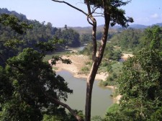Southeast Asia is one of the world’s fastest growing travel destinations. The area offers everything from beautiful tropical islands and pristine beaches to thick jungles, diverse cultures, cuisines, and people. Southeast Asia has some of the best national parks and reserves in the world, an abundance of fascinating World Heritage sites, a variety of spiritual places to visit that represent the religions of the region like Buddhism, Taoism, Islam, and Christianity, and it has a huge supply of beaches and associated activities. Some of the many exciting Southeast Asian highlights include:

Taman Negara National Park, Malaysia
This lush park is located on Malaysia’s east coast. The variety of plants and wildlife are amazing and the scenery includes lazy, winding rivers and roaring waterfalls.

Angkor Wat, Cambodia
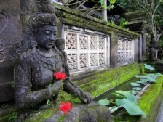Angkor Wat, means “City Temple”, and is a complex of ancient temples that is considered the most important architectural site in Southeast Asia. It was built in the 12th century to honour Vishnu, the Hindu god.

Bali, Indonesia
Land of the Buddha! Kuta, Ubud, Amed, and Sanur are all worth visiting. For the best surfing and nightlife, head over to Kuta beach. For relaxation, head up to Ubud, or even Amed if you’re really looking for peace and quiet.

Halong Bay, Vietnam
Halong Bay is one of the world’s natural wonders made up of at least 3000 islands in the Gulf of Tonkin, Vietnam. This is a World Heritage site that offers breathtaking views, many caves worth exploring, and hiking in Cat Ba National Park.

The Philippines
In the Philippines you’ll find beautiful white beaches like Boracay, which is on the list of the world’s best beaches. But there is more to the Philippines than just the beaches. The scenery also includes breathtaking waterfalls and miles of rice terraces.

LOCATING MAIN IDEA

- One useful way to understand the main idea of a paragraph is to start by identifying the paragraph’s topic. A paragraph’s topic is the subject under discussion. When identifying the topic of a paragraph, remember that it should be general enough to cover the material in the paragraph, but not so general that the label could apply to many paragraphs.

- Look at this paragraph to illustrate.
Beginning in the late tenth century, many new cities and towns were founded, particularly in northern Europe. Usually, a group of merchants established a settlement near some fortified stronghold, such as a castle or monastery. Castles were particularly favored since they were usually located along major routes of transportation or at the intersection of two such trade routes; the lords of the castle also offered protection. If the settlement prospered and expanded, new walls were built to protect it.
The main idea is often found in the first sentence of a paragraph; however, you may find it in other locations; that is, in the last sentence, in the middle sentence, split between the first and the last sentences or not stated in the paragraph at all.

Study the sample paragraphs below and notice the locations of the main idea and its relationship with the other sentences in the paragraph.

- Main Idea in the first sentence
You no doubt have an image of who you are: this is your self-concept. It consists of your feelings and thoughts about your strengths and weaknesses, your abilities and limitations. Your self-concept develops from at least three sources: (1) the image of you that others have and that they reveal to you, (2) the comparisons you make between yourself and others, and (3) the way you interpret and evaluate your own thoughts and behaviours.

- Main Idea in the last sentence
The open self represents all the information that both you and others know about yourself. The blind self represents all the things that you don’t know about yourself that others do know. The hidden self contains all that you know of yourself and of others that you keep secret. The unknown self represents truths about yourself that neither you nor others know. Thus, your self-awareness is how much you know about yourself according to the model of the four selves.

- Main Idea in the middle sentence
When you think you’re a failure, you’re more likely to act like a failure. When you think you are successful, you are more likely to act like a success. When you feel good about yourself – about who you are and what you are capable of doing – you will perform better. Self-esteem is very important because success breeds success. Increasing self-esteem will, therefore, help you to function more effectively in school, in interpersonal relationships, and in careers.
- Unstated main idea (implied)

- Sometimes the main idea is not stated in any particular sentence but each sentence contains details that lead to a common idea. In order to arrive at the main idea, you have to read every sentence and figure out what they have in common.
- People in the United States disclose more than those in Great Britain, Germany, Japan, or Puerto Rico. American students also disclose more than students from nine different Middle East countries. Singaporean-Chinese students consider more topics to be taboo and inappropriate for self-disclosure than their British colleagues. In Japan it is considered undesirable to reveal personal information whereas in much of the United States it is not only considered desirable, it is expected.
- From the above paragraph, you can notice that all of the sentences are about “self-disclosure.” Also, you can see that the subject of each sentence is people from different countries and cultures. Each sentence talks about how much people from different cultures are willing to tell about themselves. If you put all this information together, you can come up with a main idea sentence such as “People from different countries have different degrees of self-disclosure.”

- When the main idea of a passage is not clear because each paragraph has a different main point, a question identifying the main topic of the passage will be asked. The following are examples of main idea questions:

What is the main idea of the passage?
With what topic is the passage mainly concerned?
What does the passage mainly discuss?
What is the main idea expressed in the passage?
The primary idea of the passage is...
The main topic of the passage is...

Read the following passages and find the main idea of each one.

Because different tree species adapted to different climates and soil types have evolved over millennia, many kinds of forests occupy the earth today. The primitive forests of several hundred million years ago consisted of fewer kinds of trees. In fact, the earliest “trees,” which grew nearly 500 million years ago, were like giant club mosses. They lacked true roots and consisted of a tangle of specialized branches that clambered over rocky ground. Fifty million years later came the dense forests of tree ferns that prevailed in tropical climates of that era. The forerunners of modem conifers were on the scene 300 million years ago, when plant life abundantly colonized marshy land, building the tremendous coal and oil reserves so important today. By the time the dinosaurs roamed the earth some 180 million years ago, during the Cretaceous period, seed-bearing trees had evolved that shed their leaves in winter; from these have sprung the angiosperms and our present deciduous forests.

- What is the main idea of the passage?

(A) Conifers are the oldest trees in today’s forests.
(B) Climate affected the development of trees over millennia.
(C) The predecessors of today’s forests were giant club mosses and tree ferns.
(D) The variety of trees in today’s forest are a result of millions of years of evolution.

Innovations in transportation in the 1800s permitted space to be traversed more rapidly and were crucial to the industrial expansion of the North. The great spaces that separated producers from consumers made speed essential, especially in the movement of perishable freight. The development of the steam-powered locomotive in the 1830s and the rapid extension of the railways in the 1840s and 1850s provided the answer to the need for faster transport and dramatically altered patterns of economic development throughout the United States. In 1830 there were 32 miles of rails in the country, in 1840 there were 2,818 miles, and by 1850 there were more than 9,000 miles. The rapid extension of rail mileage enabled the railroads significantly to reduce their costs for shipping freight and carrying passengers, thus enabling them to price their services more cheaply and competitively. The extension of trunk lines, into which short or local lines fed, further tightened the east-west flow of commerce and bound the Northeast and the old Northwest together with bands of steel.

- What is the main theme in the passage?

(A) Railroad made the transportation of perishable freight possible.
(B) Between 1830 and 1850 over 8,000 miles of railroad track were laid.
(C) Railroads provided an important link between the Northwest and the Northeast.
(D) Railroads had a profound effect on the economic development of the U. S. in the 19th century.

Hawaii was originally settled by the natives of the South Pacific, who arrived in the islands in canoes laden with breadfruit, coconut, bananas, pigs, and chickens. Supplementing these foods were over a hundred different edible fishes and forty kinds of seaweed from the surrounding waters. Hawaiian food was eaten raw or wrapped in taro leaves, seasoned with coconut, and cooked. In the early 1800s, the whalers and missionaries introduced stews, chowders, curries, Corned beef, dried beef, salt salmon, and cornstarch puddings. Most likely, pipkaula (jerked beef), salmon, and haupia (coconut pudding) evolved during this period.
In the late nineteenth century immigrants from China, Japan, and Korea were brought to Hawaii to work the sugar plantations. The Chinese brought rice, soybeans, and vegetables and their ways of cooking them. The Japanese brought sukiyaki and teriyaki, among many other foods. Settlers from the continental United States also brought their favourite recipes and in the spirit of aloha, the Hawaiians have accepted each group’s offerings and drawn the best from them. Thus a Hawaiian feast is a gastronomic experience, the essence of Hawaii and its many cultures.

- What is the main topic of the passage?

(A) Whalers and missionaries introduced new kinds of foods to the people of Hawaii.
(B) Sugar plantations were worked by immigrants from Asia, who brought their native foods with them.
(C) Hawaiian food is a combination of the foods of many peoples and a reflection of Hawaii’s history.
(D The natives of the South Pacific who first settled in Hawaii ate raw food, whereas other
immigrants cooked theirs.

Strictly speaking, cartography is the drawing or compiling of maps. The explorers and surveyors go out and make the measurements and gather the information from which the cartographers draw their maps. Sometimes the fieldwork and the creation of the map are done by the same person. But when the scope is broad and the sources of information many, maps are more often a compilation of that information. They represent the accumulated work of many people, brought together under the supervision of one person, the compiler. The value of the map depends, of course, on the expertise of the compiler, who must sift through available information, select the most accurate data, and come up with a thoughtful and accurate synthesis of the geographic knowledge of the region.

- What is the main idea of the passage?

(A) The definition of cartography is the drawing or compiling of maps.
(B) Maps are the product of a group effort brought together usually by one person.
(C) Not all of the information initially compiled for maps is accurate.
(D) The compiler’s task is more important than that of the explorers and surveyors.

PART III
READING

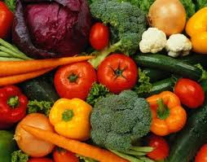GETTING INTO THE TOPIC

- Discuss the following questions with your classmates.

  - How important is food in your life? What does food mean to you?
  - Do you agree that if something tastes great, it is probably bad for you?

- What is more important: taste or nutrition?

- Read the paragraph and complete the chart.
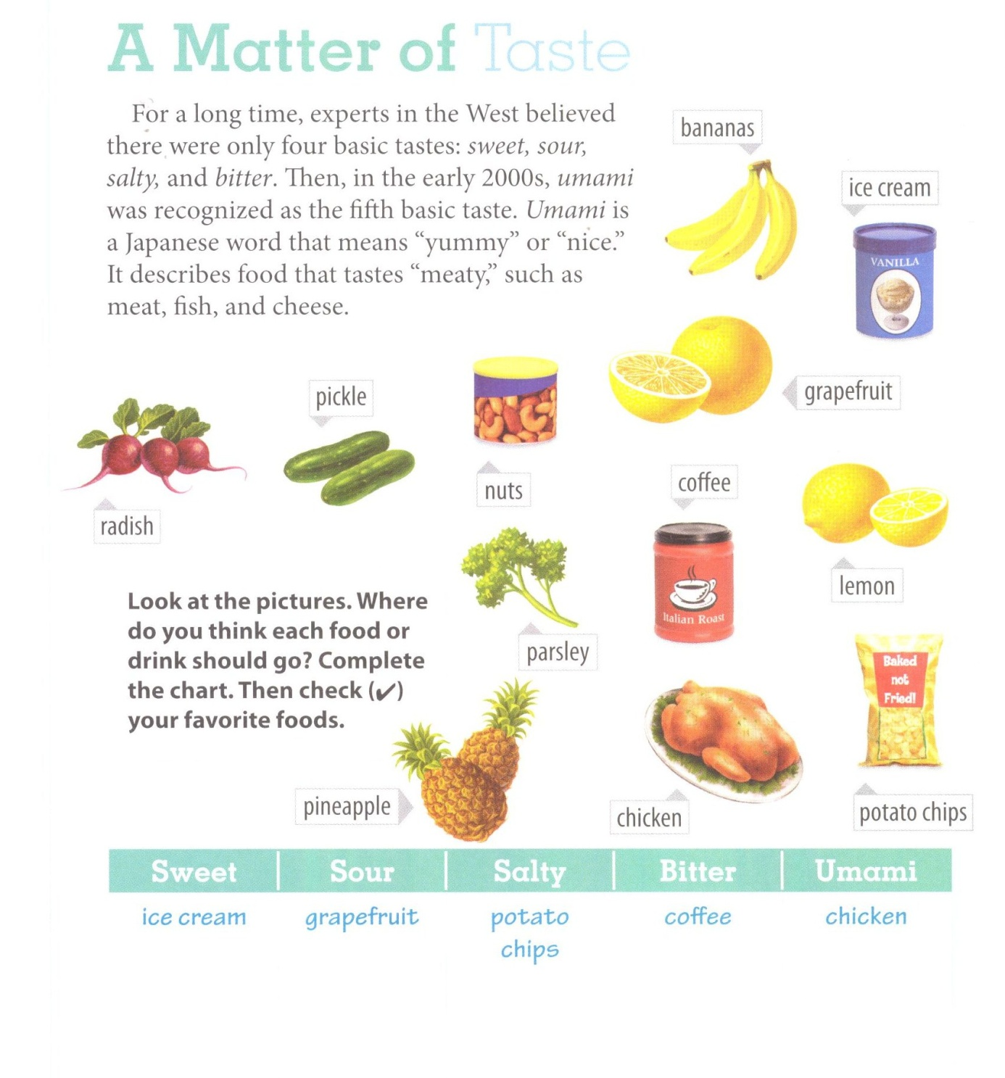

sweet | sour | salty | bitter | Umami /umami/
Pineapple  Banana  Ice cream | Lemon  Grapefruit  Pickle | Potato chips  Nuts | Coffee  Parsley  Radish | Chicken

- Tick your favourite foods in the chart. Which of the five basic tastes do you like best?
BECOMING ACQUAINTED WITH THE TEXT

- You are going to read an article from a health magazine about ways that we can eat well. Skim the text in three minutes by looking at the title, the picture, reading the first paragraph, subheadings, the 1st sentences of each paragraph and the final paragraph. Write answers to these questions.

- Does the author think science should help us choose the foods we eat?
No. the author doesn’t think science should help us choose the foods we eat. He
thinks common sense should.

- What suggestions for eating well do you think the author will talk about? Write as many as you
can.

  - ____________Answers will vary______________________________________________
  - _________________________________________________________________________________
  - _________________________________________________________________________________
3. The main idea of the whole text is that making healthy food choices and eating well are not difficult.

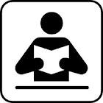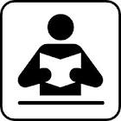

Eating Well:
Less Science, More Common Sense

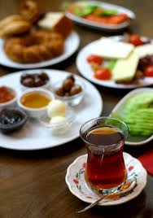1 Food is life. We eat food to grow, stay healthy, and have the energy to do everyday activities. Some of the food which we consume makes all of these things possible, but some do not. For example, studies have shown that children who eat a rich breakfast can concentrate longer, remember more, and participate more actively in class, whereas the students with a poor diet usually have problems with their lessons. Research has also shown that adults who have a healthy diet perform better on the job and miss fewer days of work. As a result, we can see that our food choices affect our health and behaviour, so we must do more than just eat; we must eat well. However, making healthy food choices is not easy for many people today.

2 There is a lot of information which tells us what's good for us and what isn’t. However, usually this information is more confusing than being helpful. In fact, different research about the same food often creates opposite results. Take one example: food studies done on eggs. For years, research showed a link between eating eggs and high cholesterol. Scientists advised us to limit or completely remove eggs from our diets so that dangerous illnesses like cancer or heart disease would be prevented. However, recent studies now say that eggs are actually good for you and that most people can - and even should - eat one a day. It's hard to know who to believe.

3 Shopping for food can also be challenging. We often need to make many different choices when we go to a supermarket. Should you buy this cereal or that one? Normal or fat-free milk? Meat or chicken? It is hard to know which to choose, especially when two items are very similar. Many shoppers read product labels to decide. Of course, people mostly buy items with the words "doctor recommended," "low fat," or "all natural" on them. But are these foods really better for you? Probably not. Indeed, many food labels are often misleading. For instance, doctors sometimes recommend that people should eat yogurt for their digestion, related to this a yogurt company might use the label "doctor recommended" and you buy their product. In reality, although their specific yogurt isn't preferred by doctors, shoppers may think it is because of the food label.

4 So how do we make healthy choices? Prof. Michael Pollan (the University of California, Berkeley) has written many books about eating well (including the bestseller “In Defense of Food”). In his opinion, our food should be prevented from the "unnecessary stress” caused by "nutrition science and the food industry.” According to Pollan, we should stop reading labels and listening to the scientific experts. Instead, he offers some simple and practical tips for eating well and staying healthy.

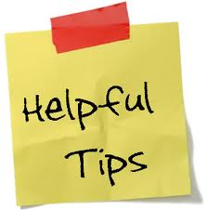5 Tip 1: "Eat a balanced diet, but mostly plants." In other words, only eat "real food" which your great-grandparents would name as food. Make fruit and vegetables your main source of food and limit the amount of meat you eat. Eat well, but not too much. Prof. Pollan quotes the Okinawan people of Japan who have an expression: "Here Hachi Bu: eat until you are 80% full."

6 Tip 2: "Get out of the supermarket whenever possible.” Shopping for meat or dairy products at the market is okay; on the other hand a supermarket is also full of items like noodles, diet sodas, and similar products - the ones that aren't good for us. Instead, try to shop at a farmers' market or a local store. The food there is fresher and healthier.

7 Tip 3: Pollan says that eating is not only about physical health and nutrition. "Food is also about pleasure, about society and family." Learning how to cook and sharing a meal with others are obviously important parts of eating well and being healthy.

8 In addition, the third tip is helping people to reconnect with food traditions. In cities around the world, for example, urban gardens which were common in the past are becoming popular again, where neighbours are working together to grow fruit and vegetables. There are several advantages of these gardens. First, people have access to more fresh fruit and vegetables, especially poorer people who cannot spend enough money on these items. Second, the food costs less than it would in a supermarket. Furthermore, working together in the garden helps people to exercise, and finally it supports community and sharing. This will help you have a happier mood.

9 Urban gardens have been used to teach children about food production and healthy eating. They attract their attention very much. At the Edible Schoolyard - a program at a public school in the U.S. - children learn how to plant and pick up fruit and vegetables. They learn how to clean and prepare them for meals - a skill that they will be able to use all their lives. They like learning healthy eating habits, they want to eat the things they have grown. These gardens are getting popular day by day.

10 In conclusion, making healthy food choices and eating well are not difficult. Be wise and do simple things. Changing your shopping habits, learning to cook, planting a garden, and limiting your eating of certain foods can result in a better diet and a healthier you. Bon appétit!

- Read the statements. Would the writer of the magazine article agree with them?
Write “Y” (yes) or “N” (no).

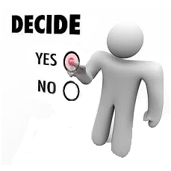__N__ 1. Scientific research about diet and health usually gives us helpful information.
__N__ 2. Reading food labels has made us better informed, healthier consumers.
__Y_ 3. We don’t need experts to tell us what to eat.
_ Y__ 4. A lot of food found in a supermarket is not “real food.”
_ N__ 5. The purpose of eating is mainly for health and nutrition.
__Y__ 6. An urban garden is an old tradition that works well in modern cities.

LOOKING FOR DETAILS

- Answer the questions according to the reading text.

- According to the reading, which question is difficult for many people to answer today?

  - Why do some people have a healthier diet than others?
  - How does your diet affect our health and behavior?
  - Which are the healthiest foods to eat?

- In paragraph 2, the studies on eggs are an example of ____ from the scientific community.

  - confusing results
  - helpful advice
c) similar findings

- Food labels that read “low fat” or “all natural” ____.

  - are usually on products recommended by doctors
  - are primarily used to sell a product
  - often help shoppers make healthy food choices

- Which piece of advice would Michael Pollan probably agree with?

  - Try to eat only one meal per day; you’ll feel better and be healthier.
  - Selecting healthy food and learning how to cook it are both important.
  - Never shop at a supermarket; the food there is unhealthy.

- At the Edible Schoolyard in the U.S., what are children not learning to do?

a) Plant fruit and vegetables.
b) Cook and eat healthy meals.
c) Read and understand nutrition labels.

VOCABULARY STUDY

- Match the words with their meanings.

- Consume __d____ a) effective or successful
- Confusing _ _f____ b) easily noticed, seen
- Practical __a____ c) the way you are feeling
- Obviously __b____ d) eat or drink
- Mood __c____ e) sensible in making decisions
- Wise __e____ f) unclear, difficult to understand

- Fill in the blanks with one of the suitable words below.

mood | practical | obviously
consume | wise | confusing

- Eating a large meal before you go to bed isn’t very _ practical ____________. It won’t be a useful thing if you want a good sleep.

- People _ consume ____________ too much water today. If they continue wasting this important resource at this rate, we won’t have enough of it in 10 years time.

- You look very depressed nowadays. You should try to change your _ mood ____________ and be a bit more relaxed. Otherwise, this feeling will affect your health badly.

- It was very clear that Merdivenspor lost the match, because its supporters were obviously _ sad while leaving the stadium.

- A _ wise _______________ person is clever and makes logical decisions in any case.

- To stay with her family or go abroad became a really _ confusing ____ situation for Mary and seemed hard to decide.

